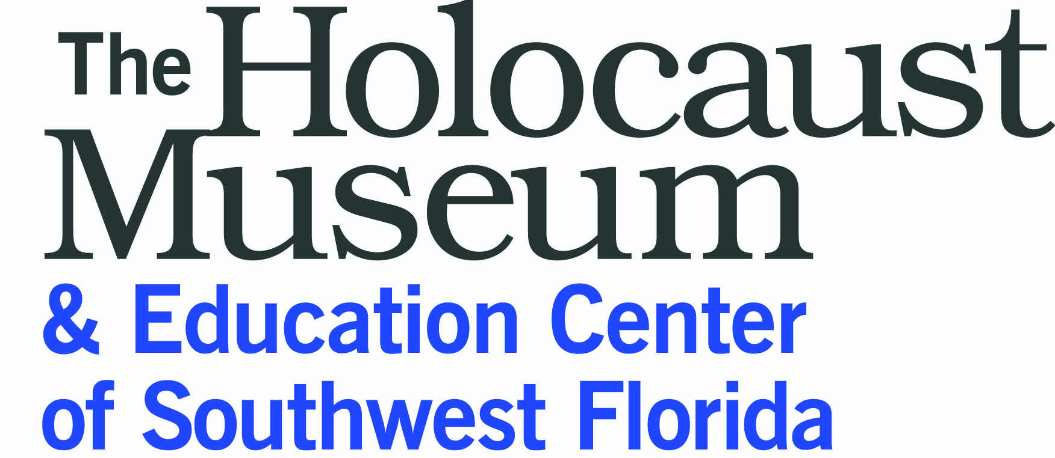
and The Merrill Kuller Educator Series present
11th Annual Professional Development Seminar
Legacy & Leadership in History:
A World War II and Holocaust Seminar for Educators
Registration due July 28, 2014
Name: ____________________________________________________________________________________
Mailing address: ______________________________________________________________________________________________________________________________________________________________________________________
Phone number: ______________________________________________________________________________
Most accessible email: ________________________________________________________________________
School/grade/discipline: _______________________________________________________________________
Please explain briefly why you feel it’s important to incorporate the Holocaust into your teaching and how you would expect to use the information and materials gained in this seminar. Use additional space on the back or another sheet of paper if necessary. _______________________________________________________________________________________________________________________________________________________________________________________________________________________________________________________________________________________________________________________________________________________________________________________________________________________________________________________________________
Have you attended other Holocaust Education seminars? If so, where? ___________________________________________________________________________________________

Return this application, with a check for $45 payable to the Holocaust Museum & Education Center of SWFL, no later than July 28, 2014.
.
Sam Parish
Holocaust Museum & Education Center of Southwest Florida
4760 Tamiami Trail N., Suite 7, Naples, FL 34103 www.holocaustmuseumswfl.org

