Max Schmeling
- Full name: Maximillian Adolph Otto Siegfried Schmeling
- Born September 28, 1905 in Germany
- German boxer and world heavyweight champion
- Had a Jewish-American manager, Joe Jacobs
  - Pressured by the Nazi party to fire him
  - Schmeling refused
- Asked by Hitler to join the Nazi party
  - Schmeling also refused
- Saved the lives of his friend’s two sons, Henry and Werner Lewin, during Kristallnacht
  - November 9, 1938
  - Hid them in his hotel room in Berlin
  - Informed the public that he was sick and was not to be disturbed
  - Eventually, helped them escape to America
- Hitler assigned him to the German military as a paratrooper
  - Sent him on suicide missions
- Died February 2, 2005 in Wenzendorf, Germany at the age of 99

Chiune Sugihara
- Born on January 1, 1900 in Japan
- Was a Japanese diplomat and Japan’s consul in Lithuania in 1940
- Responsible for monitoring Soviet and German troop movements
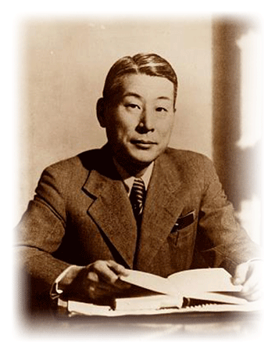
- When the Nazis closed in on Lithuania, Chiune broke protocol
  - Felt he had a duty to save the Jews from the coming Nazis
- Wrote fake visas, allowing Jews to flee to Japan
  - Altogether, issued 2,140 visas
- After the war, Mr. Sugihara was forced to resign
- No one knew about his righteous deed until 1960
  - Was located by a man whom he helped save
- Honored with an award ceremony in Israel, in 1985
- Later declared “Righteous Among Nations”
  - Classified by Israel as Righteous Among the Nations if you are a non Jew who saved Jewish lives during the Holocaust
- Died on July 31, 1986
“Do what is right because it is right, and leave it alone.”
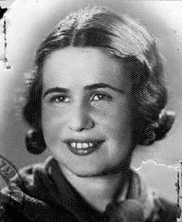
Irena Sendler
- Born in 1910 in Warsaw, Poland and grew up to be a social worker
- In 1942, the Warsaw Ghetto was built
- She was so disgusted by what was happening to the Jews that she joined the Zegota- The Council for Aid to Jews
  - An underground Polish resistance group
- Irena was granted permission to enter the Warsaw Ghetto daily
  - On visits she would smuggle in food, clothes and medicine
- Irena realized this was not enough and started to smuggle out the children
  - She convinced the parents to let her take their child and gave the children false identities to place them in homes or orphanages.
  - Kept their real identities written on a list that was placed in a jar
    - The jar was hidden under an apple tree in her neighbor’s yard
- She helped save about 2,500 Warsaw children
- The Nazis found out and arrested Irena
  - Was saved by her friends in the Polish underground who bribed the guards to let her go
- She died in 2008
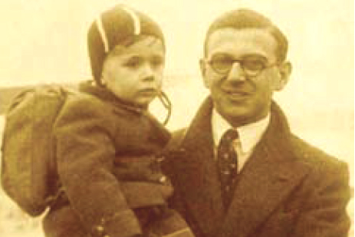
Nicholas Winton
- Full name: Nicholas Wertheimer
- Born on May 19, 1909 in England
- Was a stockbroker by trade
- Organized a rescue operation for children in Czechoslovakia after visiting a refugee camp in Prague, in which he witnessed thousands of people living in appalling conditions
- Raised money to fund the transport of the children from Czechoslovakia to England
  - Also worked to find British families willing to adopt the Jewish children
- First transport of children to England left on March 19, 1939
  - One day before Germany invaded Czechoslovakia
- Transports stopped when Germany invaded Poland in September 1939 and World War II began.
- Rescued 669 Czech children altogether
- Was knighted by Queen Elizabeth II for his humanitarian efforts
- He recently celebrated his 104th birthday
Albanian Besa
- Besa is Albania’s ethical code of honor
  - It means, “To keep the promise.”
- Albania was the only European country to take in a larger number of Jewish people than it had housed before the Holocaust
- More than 2,000 Jews from Greece, Italy and other nations were hidden in Albania during WWII
  - By Muslim families
- The Albanian population refused to turn over a list of Jews who were residing in their country to the Nazis
- Government agencies provided Jews with fake documents allowing them to intermingle with the rest of the population
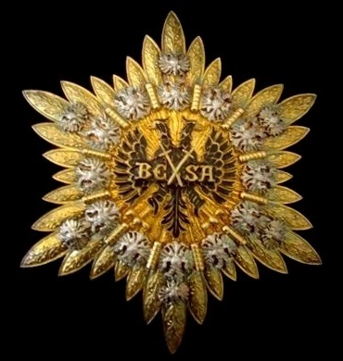
“There is no trace of any discrimination against Jews in Albania, because Albania happens to be one of the rare lands in Europe today where religious prejudice and hate do not exist, even though Albanians themselves are divided into three faiths.”
    - Herman Bernstein, the United States
Ambassador to Albania in 1934
Le Chambon-Sur-Lignon
- A small village in south-central France
- Provided refuge for over 5,000 people, 3,000-3,500 of them being Jews
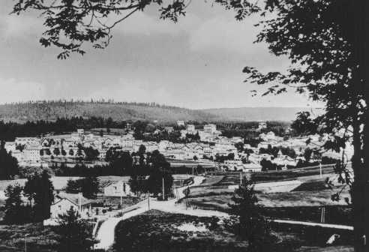
- Rescue was led by Pastor Andre´ Trocme´, his wife Magda, and Pastor Edouard Theis
- The residents of the village provided shelter in homes, hotels, schools and farms
  - Were inspired by religious conviction and a sense of moral duty
- Villagers also forged ration cards and identification papers and often led the refugees across the border to Switzerland
  - Switzerland was neutral territory
- Pastor Trocme´ contacted American Quakers in order to set up a system allowing supplies to enter Jewish internment camp
- The Quakers were able to get the Jews released from the camp, and Le Chambon took them in from 1940-1944
- Though the refugee children often attended Protestant religious services, Pastor Trocme´ encouraged them to hold Jewish services as well.

