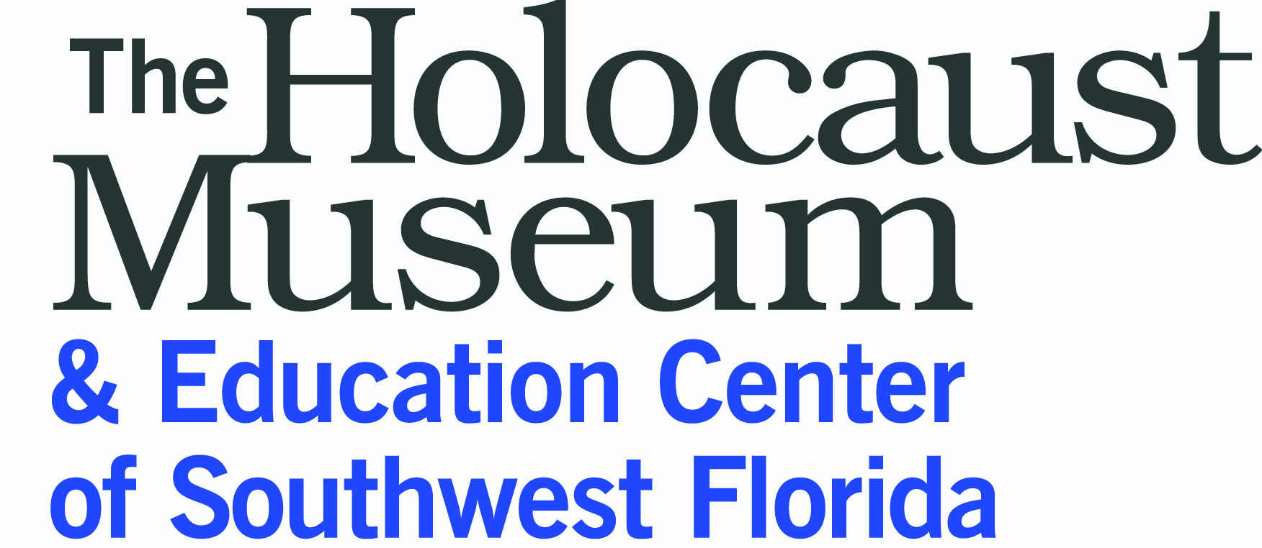
and The Merrill Kuller Educator Series present
11th Annual Professional Development Seminar
Legacy & Leadership in History:
A World War II and Holocaust Seminar for Educators
Registration due Month, Day, 2014
Name: ____________________________________________________________________________________
Mailing address: ______________________________________________________________________________________________________________________________________________________________________________________
Phone number: ______________________________________________________________________________
Most accessible email: ________________________________________________________________________
School/grade/discipline: _______________________________________________________________________
Please explain briefly why you feel it’s important to incorporate the Holocaust into your teaching and how you would expect to use the information and materials gained in this seminar. Use additional space on the back or another sheet of paper if necessary. _______________________________________________________________________________________________________________________________________________________________________________________________________________________________________________________________________________________________________________________________________________________________________________________________________________________________________________________________________
Have you attended other Holocaust Education seminars? If so, where? ___________________________________________________________________________________________
Preference will be given to teachers who have NOT previously attended one of our seminars and those within our geographic region of Charlotte, Collier, Glades, Hendry and Lee Counties. If space is available, a seat will be offered to teachers in order of application receipt. Return this application, with a check for $45 payable to the Holocaust Museum & Education Center of SWFL, no later than Month, Day, 2014.
Sam Parish
Holocaust Museum & Education Center of Southwest Florida
4760 Tamiami Trail N., Suite 7, Naples, FL 34103 www.holocaustmuseumswfl.org

